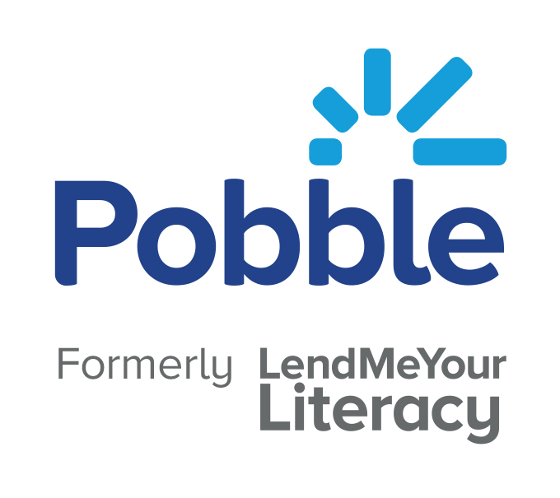
Pobble Education Ltd

Subject: Pobble Proposal for [School name]

Proposal valid until [date]

Dear [Name],

Thank you for your interest in Pobble. Please find attached a Pobble proposal of Pobble costs.

Pobble 365 subscription

You can purchase a whole school Pobble Teaching and Learning subscription for £360. This gives you unlimited teacher access for 12 months to all of our Pobble 365 lessons as well as a range of other resources.

Signing up

All subscriptions can be purchased online at https://www.pobble.com/pricing.

Our online system allows for payment via Card, Paypal or Bank Transfer. You can also add a PO number before generating your online invoice,

Full set up support is provided including access to our help desk. Renewal reminders are sent out approximately 30 days prior to your renewal date.

If you do have any questions ahead of your purchase please do not hesitate to contact me.

Kind regards,

Simon Blower

simon@pobble.com

Terms and conditions

